Project Design Phase-II

**Technology Stack (Architecture & Stack)**

|  |  |
| --- | --- |
| Date | 03 October 2022 |
| TeamID | PNT2022TMID07290 |
| Project Name | Plasma Donor Application |
| Maximum Marks | 4 Marks |

**Technical Architecture:**

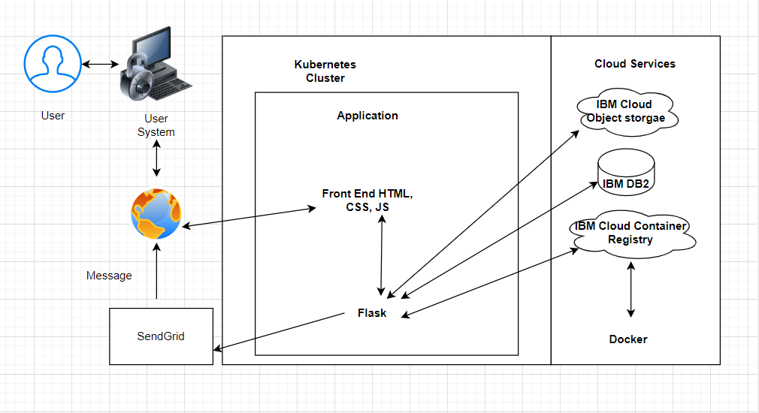

**Components & Technologies:**

|  |  |  |  |
| --- | --- | --- | --- |
| **SL. NO** | **COMPONENT** | **DESCRIPTION** | **TECHNOLOGY** |
| 1 | Website | Donors can proceed to the website to register and patients can use them to post a request. | HTML, CSS, JavaScript |
| 2 | Docker | Service for storing the private container images | Container Registry |
| 3 | Kubernetes | Manage the complete process in the stable state If any software crash it automatically restart the work | Kubernetes |
| 4 | DB | Data types are String, Numeric, Date, time, and timestamp distinct types.  Act sort mem limit, autodelrecobj, auto main configuration. | MySQL |
| 5 | Cloud Database | A fully managed cloud database with AI capabilities that keep our website running 24*7. | IBM DB2 |
| 6 | External API | Sends email alerts on a request of plasma by the patients. | SendGrid |
| 7 | Infrastructure (Server / Cloud) | Application Deployment on Local System / Cloud Local Server Configuration: Anaconda  Cloud Server Configuration: IBM cloud | Local, Cloud Foundry, Kubernetes, etc. |

**Application Characteristics:**

|  |  |  |  |
| --- | --- | --- | --- |
| **S. NO** | **CHARACTERISTICS** | **DESCRIPTION** | **TECHNOLOGY** |
| 1. | Open-Source Frameworks | Cloud Stack, Eucalyptus. Open Nebula, App Scale,  Docker. | Docker |
| 2. | Security Implementations | Authentication and password management Accountability to authorize and monitor the use  anonymous accounts and to  remove | Encryptions, Secured Authorization. |
| 3. | Scalable Architecture | To expand our server capacity, memory, or disc space | IBM DB2 |
| 4. | Availability | The administrator needs to look up the stock availability  in the database | Docker |
| 5. | Performance | Speed up the webpage  Site optimization based on data analysis. | Kubernetes |